UNITED STATES
SECURITIES AND EXCHANGE COMMISSION
Washington, D.C. 20549
FORM 8-K
CURRENT REPORT
Pursuant to Section 13 or Section 15(d)
of the Securities Exchange Act of 1934
Date of Report (Date of earliest event reported): August 3, 2026
SYMBOTIC INC.
(Exact name of registrant as specified in its charter)
Delaware |  |  |  |  |  | 001-40175 |  |  |  |  |  | 98-1572401
(State or other jurisdiction of  incorporation or organization) |  |  |  |  |  | (Commission  File Number) |  |  |  |  |  | (I.R.S. Employer  Identification Number)
200 Research Drive  Wilmington, MA |  |  |  |  |  | 01887
(Address of principal executive offices) |  |  |  |  |  | (Zip Code)
(978) 284-2800
Registrant’s telephone number, including area code
Not Applicable
(Former name or former address, if changed since last report)
Check the appropriate box below if the Form 8-K filing is intended to simultaneously satisfy the filing obligation to the registrant under any of the following provisions:
☐ |  |  | Written communications pursuant to Rule 425 under the Securities Act (17 CFR 230.425)
☐ |  |  | Soliciting material pursuant to Rule 14a-12 under the Exchange Act (17 CFR 240.14a-12)
☐ |  |  | Pre-commencement communications pursuant to Rule 14d-2(b) under the Exchange Act (17 CFR 240.14d-2(b))
☐ |  |  | Pre-commencement communications pursuant to Rule 13e-4(c) under the Exchange Act (17 CFR 240.13e-4(c))
Securities registered pursuant to Section 12(b) of the Act:
Title of each class |  |  |  |  |  | Trading  Symbol(s) |  |  |  |  |  | Name of each exchange  on which registered
Class A common stock, par value $0.0001 per share |  |  |  |  |  | SYM |  |  |  |  |  | The Nasdaq Stock Market LLC
Indicate by check mark whether the registrant is an emerging growth company as defined in Rule 405 of the Securities Act of 1933 or Rule 12b-2 of the Securities Exchange Act of 1934.
Emerging growth company ☐
If an emerging growth company, indicate by check mark if the registrant has elected not to use the extended transition period for complying with any new or revised financial accounting standards provided pursuant to Section 13(a) of the Exchange Act. ☐

.

Item 2.02Results of Operations and Financial Condition
On August 5, 2026, Symbotic Inc. (the “Company”) issued a press release announcing its financial results and other information for the fiscal quarter ended June 27, 2026. A copy of the press release is furnished as Exhibit 99.1 to this Current Report on Form 8-K and is incorporated by reference herein.

The information furnished pursuant to this Item 2.02, including Exhibit 99.1, shall not be deemed “filed” for any purpose, including for the purposes of Section 18 of the Securities Exchange Act of 1934, as amended (the “Exchange Act”), or otherwise subject to the liabilities of that Section, nor shall it be deemed incorporated by reference in any filing under the Securities Act of 1933, as amended (the “Securities Act”), or the Exchange Act, regardless of any general incorporation language in such filing, except as shall be expressly set forth by specific reference in such filing.

Item 5.02 Departure of Directors or Certain Officers; Election of Directors; Appointment of Certain Officers; Compensatory Arrangements of Certain Officers.
On August 3, 2026, the Board of Directors (the “Board”) of the Company approved an increase in the size of the Board from nine to ten members, effective August 4, 2026, and appointed Stephen G. Pagliuca to the Board, also effective August 4, 2026.

Mr. Pagliuca is the Founder and CEO of PagsGroup, a growth capital investment firm with expertise in biotech, technology, media, and sports. Mr. Pagliuca is also a Chairman and Principal Owner of Atalanta B.C., a Series A football club. Previously, he was a Managing General Partner and Co-Owner of the Boston Celtics, where he served as Chairman of the Basketball Committee and as Founder and President of the Boston Celtics Shamrock Foundation. He is also a former Co-Chair of Bain Capital, where he continues to serve as a Senior Advisor. Mr. Pagliuca holds a B.A. from Duke University and an M.B.A. from Harvard Business School.

Mr. Pagliuca will be compensated for his service as a director pursuant to the Company’s non-employee director compensation program that entitles our non-employee directors to a cash retainer for service on the Board and for service on each committee on which the director is a member. A description of the Company’s non-employee director compensation arrangements can be found in the section titled “Director Compensation” in the Company’s definitive proxy statement for its 2026 annual meeting of stockholders filed with the Securities and Exchange Commission (“SEC”) on January 16, 2026 and incorporated herein by reference. Mr. Pagliuca has also entered into an indemnification agreement with the Company, the form of which is attached as Exhibit 10.4 to the Company’s Annual Report on Form 10-K for the fiscal year ended September 27, 2025 filed with the SEC on November 24, 2025 and is incorporated by reference herein.

Item 7.01 Regulation FD Disclosure

On August 5, 2026, the Company posted on its investor relations website a supplemental presentation relating to its financial results and other information for the fiscal quarter ended June 27, 2026. A copy of the supplemental presentation is furnished as Exhibit 99.2 to this Current Report on Form 8-K and is incorporated by reference herein.

The information furnished pursuant to this Item 7.01, including Exhibit 99.2, shall not be deemed to be “filed” for any purpose, including for purposes of Section 18 of the Exchange Act, or otherwise be subject to the liabilities of that Section, nor shall it be deemed to be incorporated by reference in any filing under the Securities Act or the Exchange Act, regardless of any general incorporation language in such filing, except as shall be expressly set forth by specific reference in such filing.

Item 9.01Financial Statements and Exhibits.
(d)Exhibits
Exhibit |  |  |  |  |  | Description
99.1 |  |  |  |  |  | Symbotic Inc. Press Release, dated August 5, 2026
99.2 |  |  |  |  |  | Symbotic Inc. Investor Presentation, dated August 5, 2026
104 |  |  |  |  |  | Cover Page Interactive Data File (embedded within the Inline XBRL document)

SIGNATURE
Pursuant to the requirements of the Securities Exchange Act of 1934, the registrant has duly caused this report to be signed on its behalf by the undersigned hereunto duly authorized.
Date: August 5, 2026
Symbotic Inc.
By: |  |  |  |  |  | /s/ Maria G. Freve
Name: |  |  |  |  |  | Maria G. Freve
Title: |  |  |  |  |  | Vice President, Controller and Chief Accounting Officer  (Principal Accounting Officer)

.
Exhibit 99.1

FOR IMMEDIATE RELEASE
Symbotic Reports Third Quarter Fiscal Year 2026 Results
Steve Pagliuca, Former Co-Chair of Bain Capital, Elected to Symbotic’s Board of Directors

Wilmington, Massachusetts (August 5, 2026) -- Symbotic Inc. (Nasdaq: SYM), a leader in A.I.-enabled robotics technology for the supply chain, announced financial results for its third quarter of fiscal year 2026, which ended on June 27, 2026. Symbotic reported revenue of $721 million, up 22% year-over-year, and net income of $55 million, compared with a net loss of $21 million in the third quarter of fiscal year 2025. Adjusted EBITDA1 reached $95 million, more than double the $45 million in the third quarter of fiscal year 2025.
Cash and cash equivalents totaled $1.7 billion at the end of the third quarter of fiscal year 2026, down from $2.0 billion at the end of the second quarter of fiscal year 2026.
“We are well on track to deliver against our key objectives for our fiscal year,” said Rick Cohen, Symbotic Chairman and Chief Executive Officer. “Importantly, we are seeing increasing opportunities to broaden the scope of our work with existing and prospective customers.”
“We delivered another quarter of growth and a large expansion in our profitability,” said Izzy Martins, Symbotic Chief Financial Officer. “Looking ahead, we see a continuation of our profitable growth trajectory supported by 77 systems in deployment.”
OUTLOOK
For the fourth quarter of fiscal 2026, Symbotic expects revenue of $760 million to $780 million, and adjusted EBITDA2 of $100 million to $105 million.
WEBCAST INFORMATION
Symbotic will host a webcast today at 5:00 pm ET to discuss its third quarter fiscal year 2026 results. The webcast link is: https://edge.media-server.com/mmc/go/symbotic-q3-2026.
NEW BOARD MEMBER
Symbotic also announced the election of Steve Pagliuca to its Board of Directors, effective August 4, 2026.
Mr. Pagliuca is the Founder and CEO of PagsGroup, a growth capital investment firm with expertise in biotech, technology, media, and sports. He is also a Chairman and Principal Owner of Atalanta B.C. football club. Previously, he was a Managing General Partner and Co-Owner of the Boston Celtics, where he served as Chairman of the Basketball Committee and as Founder and President of the
1 Adjusted EBITDA (earnings before interest, taxes, depreciation, and amortization) is a non-GAAP financial measure as defined below under “Use of Non-GAAP Financial Information.” See the tables below for reconciliations to net income (loss), the most comparable GAAP measure.
2 Symbotic is not providing guidance for net income (loss), which is the most comparable GAAP financial measure to adjusted EBITDA, because information reconciling forward-looking adjusted EBITDA to net income (loss) is unavailable to it without unreasonable effort. Symbotic is not able to provide reconciliations of adjusted EBITDA to GAAP financial measures because certain items required for such reconciliations are outside of Symbotic’s control and/or cannot be reasonably predicted, such as the provision for stock-based compensation.

Boston Celtics Shamrock Foundation. He is also a former Co-Chair of Bain Capital, where he continues to serve as a Senior Advisor.
“I am delighted to welcome Steve to our Board of Directors,” said Cohen. “He brings an exceptional track record of helping high-growth companies scale, navigate complex markets, and create lasting value. His strategic insight and experience building world-class organizations will strengthen our Board as we enter our next phase of growth.”
####

ABOUT SYMBOTIC
Symbotic is an automation technology leader reimagining the supply chain with its end-to-end, A.I.-powered robotic and software platform. Symbotic reinvents the warehouse as a strategic asset for the world’s largest retail, wholesale, food & beverage, and medical supply distribution companies. Applying next-generation technology, high-density storage and machine learning to solve today's complex distribution challenges, Symbotic enables companies to move goods with unmatched speed, agility, accuracy and efficiency. As the backbone of commerce, Symbotic transforms the flow of goods and the economics of the supply chain for its customers. For more information, visit www.symbotic.com.

USE OF NON-GAAP FINANCIAL INFORMATION
Symbotic reports its financial results in accordance with Generally Accepted Accounting Principles in the United States (“U.S. GAAP”). This press release contains financial measures that are not recognized under U.S. GAAP (“non-GAAP financial measures”), including adjusted EBITDA, adjusted gross profit, adjusted gross profit margin, adjusted research and development expenses, adjusted selling, general, and administrative expenses, and free cash flow. These non-GAAP financial measures have limitations as an analytical tool as they do not have a standardized meaning prescribed by U.S. GAAP. The non-GAAP financial measures Symbotic uses may not be the same non-GAAP financial measures, and may not be calculated in the same manner, as that of other companies and, therefore, are unlikely to be comparable to similar measures presented by other companies. Rather, these non-GAAP financial measures are provided as a supplement to corresponding U.S. GAAP measures to provide additional information regarding the results of operations from management’s perspective. Accordingly, non-GAAP financial measures should not be considered a substitute for, in isolation from, or superior to, the financial information prepared and presented in accordance with U.S. GAAP. All non-GAAP financial measures presented in this press release are reconciled to their closest reported U.S. GAAP financial measures. Symbotic recommends that investors review the reconciliation of these non-GAAP financial measures to the most directly comparable GAAP financial measures provided in the financial statement tables included below in this press release, and not rely on any single financial measure to evaluate its business.
Symbotic defines adjusted EBITDA, a non-GAAP financial measure, as GAAP net income (loss) excluding the following items: interest income; income taxes; depreciation and amortization of tangible and intangible assets; stock-based compensation; business combination transaction expenses; equity method investment; internal control remediation; business transformation costs; fair value adjustments on strategic investments; restructuring charges; and other infrequent items that may arise from time to time. Symbotic defines adjusted gross profit, a non-GAAP financial measure, as GAAP gross profit excluding the following items: depreciation, stock-based compensation, and restructuring charges. Symbotic defines adjusted gross profit margin, a non-GAAP financial measure, as adjusted gross profit divided by total revenue. Symbotic defines adjusted research and development expenses, a non-GAAP financial measure, as GAAP research and development expenses excluding the following items: depreciation and amortization of tangible and intangible assets and stock-based compensation. Symbotic defines adjusted selling, general, and administrative expenses, a non-GAAP financial measure, as GAAP selling, general, and administrative expenses excluding the following items: depreciation and amortization of tangible and intangible assets; stock-
2
based compensation; business combination transaction expenses; internal control remediation; business transformation costs; and other infrequent items that may arise from time to time. Symbotic defines free cash flow, a non-GAAP financial measure, as net cash provided by or used in operating activities less purchases of property and equipment and capitalization of internal use software development costs. In addition to Symbotic’s financial results determined in accordance with U.S. GAAP, Symbotic believes that adjusted EBITDA, adjusted gross profit, adjusted gross profit margin, adjusted research and development expenses, adjusted selling, general, and administrative expenses, and free cash flow non-GAAP financial measures, are useful in evaluating the performance of Symbotic’s business because they highlight trends in its core business.

FORWARD-LOOKING STATEMENTS
This press release contains forward-looking statements within the meaning of the Private Securities Litigation Reform Act of 1995, Section 27A of the Securities Act of 1933, as amended, and Section 21E of the Securities Exchange Act of 1934, as amended. These statements include, but are not limited to, Symbotic’s expectations or predictions of future financial or business performance or conditions. Forward-looking statements are inherently subject to risks, uncertainties and assumptions. Generally, statements that are not historical facts, including statements concerning our possible or assumed future actions, business strategies, events or results of operations, are forward-looking statements. These statements may be preceded by, followed by or include the words “believes,” “estimates,” “expects,” “projects,” “forecasts,” “may,” “will,” “should,” “seeks,” “plans,” “scheduled,” “anticipates” or “intends” or similar expressions.
Forward-looking statements include, but are not limited to, statements about our ability to or expectations regarding Symbotic to:
•meet the technical requirements of existing or future agreements with its customers, including with respect to existing backlog;
•expand its target customer base and maintain its existing customer base;
•realize the benefits expected from its GreenBox Systems LLC joint venture, which is now doing business as Exol (“Exol”), the commercial agreement with Exol, the commercial agreement with Nueva Wal Mart de México, S. de R.L. de C.V and the acquisition of the Advanced Systems and Robotics business from Walmart;
•realize its outlook, including its system gross margin;
•manage the timing and cost of any product replacement, programs and related recalls;
•anticipate industry trends;
•maintain and enhance its systems;
•execute its growth strategy;
•develop, design and sell systems that are differentiated from those of competitors;
•execute its research and development strategy;
•acquire, maintain, protect and enforce intellectual property;
•attract, train and retain effective officers, key employees or directors;
•comply with laws and regulations applicable to its business;
•stay abreast of modified or new laws and regulations applying to its business;
•successfully defend litigation;
•issue equity securities in connection with future transactions;
•meet future liquidity requirements and, if applicable, comply with restrictive covenants related to long-term indebtedness;
3
•timely and effectively remediate any material weaknesses in its internal control over financial reporting;
•anticipate rapid technological changes;
•maintain the listing of the Symbotic common stock on Nasdaq; and
•effectively respond to general economic and business conditions.
Forward-looking statements also include, but are not limited to, statements with respect to:
•the future performance of Symbotic’s business and operations;
•expectations regarding revenues, expenses, adjusted EBITDA and anticipated cash needs;
•expectations regarding cash flow, liquidity and sources of funding;
•expectations regarding capital expenditures;
•the anticipated benefits of Symbotic’s leadership structure;
•the effects of pending and future legislation;
•the effects of inflation, prevailing price levels, exchange rates, changes in trade agreements and trade protection measures including tariffs and other economic factors;
•the direct and indirect effects of geopolitical conditions in the United States and in global economies, including those resulting from acts of war and conflicts and responses to such events;
•business disruption;
•disruption to the business due to Symbotic’s dependency on Walmart;
•increasing competition in the warehouse automation industry;
•any delays in the design, production or launch of Symbotic’s systems and products;
•the failure to meet customers’ requirements under existing or future contracts or customers’ expectations as to price or pricing structure;
•any defects in new products or enhancements to existing products;
•the fluctuation of operating results from period to period due to a number of factors, including the pace of customer adoption of Symbotic’s new products and services and any changes in its product mix that shift too far into lower gross margin products; and
•any consequences associated with joint ventures and legislative and regulatory actions and reforms.
Such forward-looking statements involve risks and uncertainties that may cause actual events, results or performance to differ materially from those indicated by such statements. Certain of these risks are identified and discussed in Symbotic’s Annual Report on Form 10-K for the fiscal year ended September 27, 2025, filed with the U.S. Securities and Exchange Commission (the “SEC”) on November 24, 2025. These risk factors will be important to consider in determining future results and should be reviewed in their entirety. These forward-looking statements are expressed in good faith, and Symbotic believes there is a reasonable basis for them. However, there can be no assurance that the events, results or trends identified in these forward-looking statements will occur or be achieved. Forward-looking statements are provided for the purposes of assisting the reader in understanding its financial performance, financial position and cash flows as of and for periods ended on certain dates and to present information about management’s current expectations and plans relating to the future, and the reader is cautioned not to place undue reliance on these forward-looking statements because of their inherent uncertainty and to appreciate the limited purposes for which they are being used by management. While Symbotic believes that the assumptions and expectations reflected in the forward-looking statements are reasonable based on information currently available to management, there is no assurance that such assumptions and expectations will prove to have been correct.
4
The forward-looking statements relate only to events as of the date on which the statements are made and are based on the beliefs, estimates, expectations and opinions of management on that date. Symbotic is not under any obligation, and expressly disclaims any obligation, to update, alter or otherwise revise any forward-looking statements, whether as a result of new information, future events or otherwise, except as required by law. Readers should carefully review the statements set forth in the reports that Symbotic has filed or will file from time to time with the SEC.
Any financial projections in this press release or discussed in the webcast are forward-looking statements that are based on assumptions that are inherently subject to significant uncertainties and contingencies, many of which are beyond Symbotic’s control. While all projections are necessarily speculative, Symbotic believes that the preparation of prospective financial information involves increasingly higher levels of uncertainty the further out the projection extends from the date of preparation. The assumptions and estimates underlying the projected results are inherently uncertain and are subject to a wide variety of significant business, economic and competitive risks and uncertainties that could cause actual results to differ materially from those contained in the projections. The inclusion of projections in this communication should not be regarded as an indication that Symbotic, or its representatives, considered or considers the projections to be a reliable prediction of future events.
Annualized and estimated numbers are not forecasts and may not reflect actual results.
This communication is not intended to be all-inclusive or to contain all the information that a person may desire in considering an investment in Symbotic and is not intended to form the basis of an investment decision in Symbotic. The forward-looking statements contained in this press release and other reports we file with, or furnish to, the SEC and other regulatory agencies and made by our directors, officers, other employees and other persons authorized to speak on our behalf are expressly qualified in their entirety by these cautionary statements.
INVESTOR RELATIONS CONTACT
Charlie Anderson
Vice President, Investor Relations & Corporate Development
ir@symbotic.com
MEDIA INQUIRIES
mediainquiry@symbotic.com

5
Symbotic Inc. and Subsidiaries
Consolidated Statements of Operations

 |  |  | Three Months Ended |  |  |  |  |  |  |  |  |  |  |  |  |  |  |  |  |  | Nine Months Ended
(in thousands, except share and per share data) |  |  | June 27, 2026 |  |  |  |  |  | March 28,  2026 |  |  |  |  |  | June 28, 2025 |  |  |  |  |  | June 27, 2026 |  |  |  |  |  | June 28, 2025
Revenue:
Systems |  |  | $ | 670,952 |  |  |  |  | $ | 634,496 |  |  |  |  | $ | 559,108 |  |  |  |  | $ | 1,895,740 |  |  |  |  | $ | 1,536,539
Software maintenance and support |  |  | 12,765 |  |  |  |  |  | 12,924 |  |  |  |  |  | 8,121 |  |  |  |  |  | 36,574 |  |  |  |  |  | 20,331
Operation services |  |  | 37,121 |  |  |  |  |  | 29,060 |  |  |  |  |  | 24,892 |  |  |  |  |  | 94,989 |  |  |  |  |  | 71,595
Total revenue |  |  | 720,838 |  |  |  |  |  | 676,480 |  |  |  |  |  | 592,121 |  |  |  |  |  | 2,027,303 |  |  |  |  |  | 1,628,465
Cost of revenue:
Systems |  |  | 523,607 |  |  |  |  |  | 495,551 |  |  |  |  |  | 453,967 |  |  |  |  |  | 1,489,031 |  |  |  |  |  | 1,246,745
Software maintenance and support |  |  | 3,486 |  |  |  |  |  | 3,368 |  |  |  |  |  | 1,705 |  |  |  |  |  | 9,808 |  |  |  |  |  | 5,593
Operation services |  |  | 32,835 |  |  |  |  |  | 27,609 |  |  |  |  |  | 24,607 |  |  |  |  |  | 84,178 |  |  |  |  |  | 72,476
Total cost of revenue |  |  | 559,928 |  |  |  |  |  | 526,528 |  |  |  |  |  | 480,279 |  |  |  |  |  | 1,583,017 |  |  |  |  |  | 1,324,814
Gross profit |  |  | 160,910 |  |  |  |  |  | 149,952 |  |  |  |  |  | 111,842 |  |  |  |  |  | 444,286 |  |  |  |  |  | 303,651
Operating expenses:
Research and development expenses |  |  | 43,780 |  |  |  |  |  | 51,283 |  |  |  |  |  | 49,729 |  |  |  |  |  | 138,069 |  |  |  |  |  | 150,967
Selling, general, and administrative expenses |  |  | 84,235 |  |  |  |  |  | 92,566 |  |  |  |  |  | 71,557 |  |  |  |  |  | 258,020 |  |  |  |  |  | 205,567
Restructuring charges |  |  | — |  |  |  |  |  | 12 |  |  |  |  |  | 16,361 |  |  |  |  |  | 2,685 |  |  |  |  |  | 16,361
Total operating expenses |  |  | 128,015 |  |  |  |  |  | 143,861 |  |  |  |  |  | 137,647 |  |  |  |  |  | 398,774 |  |  |  |  |  | 372,895
Operating income (loss) |  |  | 32,895 |  |  |  |  |  | 6,091 |  |  |  |  |  | (25,805) |  |  |  |  |  | 45,512 |  |  |  |  |  | (69,244)
Other income, net |  |  | 30,587 |  |  |  |  |  | 10,855 |  |  |  |  |  | 8,451 |  |  |  |  |  | 54,688 |  |  |  |  |  | 27,987
Income (loss) before income tax and equity method investment |  |  | 63,482 |  |  |  |  |  | 16,946 |  |  |  |  |  | (17,354) |  |  |  |  |  | 100,200 |  |  |  |  |  | (41,257)
Income tax benefit (expense) |  |  | 1,149 |  |  |  |  |  | (572) |  |  |  |  |  | (44) |  |  |  |  |  | (38) |  |  |  |  |  | 1,204
Loss from equity method investment |  |  | (9,631) |  |  |  |  |  | (6,945) |  |  |  |  |  | (3,776) |  |  |  |  |  | (22,375) |  |  |  |  |  | (7,831)
Net income (loss) |  |  | 55,000 |  |  |  |  |  | 9,429 |  |  |  |  |  | (21,174) |  |  |  |  |  | 77,787 |  |  |  |  |  | (47,884)
Net income (loss) attributable to noncontrolling interests |  |  | 43,327 |  |  |  |  |  | 7,460 |  |  |  |  |  | (17,251) |  |  |  |  |  | 61,543 |  |  |  |  |  | (38,982)
Net income (loss) attributable to common stockholders |  |  | $ | 11,673 |  |  |  |  | $ | 1,969 |  |  |  |  | $ | (3,923) |  |  |  |  | $ | 16,244 |  |  |  |  | $ | (8,902)
Income (loss) per share of Class A Common Stock:
Basic |  |  | $ | 0.09 |  |  |  |  | $ | 0.02 |  |  |  |  | $ | (0.04) |  |  |  |  | $ | 0.13 |  |  |  |  | $ | (0.08)
Diluted |  |  | $ | 0.09 |  |  |  |  | $ | 0.01 |  |  |  |  | $ | (0.04) |  |  |  |  | $ | 0.12 |  |  |  |  | $ | (0.08)
Weighted-average shares of Class A Common Stock outstanding:
Basic |  |  | 128,076,383 |  |  |  |  |  | 125,538,207 |  |  |  |  |  | 109,201,745 |  |  |  |  |  | 123,029,814 |  |  |  |  |  | 107,664,864
Diluted |  |  | 133,252,947 |  |  |  |  |  | 134,364,904 |  |  |  |  |  | 109,201,745 |  |  |  |  |  | 131,666,538 |  |  |  |  |  | 107,664,864

6
Symbotic Inc. and Subsidiaries
Reconciliation of Non-GAAP Financial Measures
The following table reconciles GAAP net income (loss) to Adjusted EBITDA:
 |  |  | Three Months Ended |  |  |  |  |  |  |  |  |  |  |  |  |  |  |  |  |  | Nine Months Ended
(in thousands) |  |  | June 27, 2026 |  |  |  |  |  | March 28, 2026 |  |  |  |  |  | June 28, 2025 |  |  |  |  |  | June 27, 2026 |  |  |  |  |  | June 28, 2025
Net income (loss) |  |  | $ | 55,000 |  |  |  |  | $ | 9,429 |  |  |  |  | $ | (21,174) |  |  |  |  | $ | 77,787 |  |  |  |  | $ | (47,884)
Interest income |  |  | (11,335) |  |  |  |  |  | (10,906) |  |  |  |  |  | (8,373) |  |  |  |  |  | (33,840) |  |  |  |  |  | (23,371)
Income tax expense (benefit) |  |  | (1,149) |  |  |  |  |  | 572 |  |  |  |  |  | 44 |  |  |  |  |  | 38 |  |  |  |  |  | (1,204)
Depreciation and amortization |  |  | 10,241 |  |  |  |  |  | 11,322 |  |  |  |  |  | 12,940 |  |  |  |  |  | 30,249 |  |  |  |  |  | 30,969
Stock-based compensation |  |  | 50,519 |  |  |  |  |  | 57,188 |  |  |  |  |  | 39,527 |  |  |  |  |  | 151,824 |  |  |  |  |  | 102,984
Business combination transaction expenses |  |  | 244 |  |  |  |  |  | 710 |  |  |  |  |  | 422 |  |  |  |  |  | 965 |  |  |  |  |  | 7,522
Equity method investment |  |  | 9,631 |  |  |  |  |  | 6,945 |  |  |  |  |  | 3,776 |  |  |  |  |  | 22,375 |  |  |  |  |  | 7,831
Internal control remediation |  |  | 1,486 |  |  |  |  |  | 1,931 |  |  |  |  |  | 1,795 |  |  |  |  |  | 5,832 |  |  |  |  |  | 7,046
Business transformation costs |  |  | 54 |  |  |  |  |  | 550 |  |  |  |  |  | 75 |  |  |  |  |  | 3,134 |  |  |  |  |  | 2,475
Fair value adjustments on strategic investments |  |  | (19,378) |  |  |  |  |  | — |  |  |  |  |  | — |  |  |  |  |  | (21,039) |  |  |  |  |  | (4,481)
Restructuring charges |  |  | (76) |  |  |  |  |  | 12 |  |  |  |  |  | 16,361 |  |  |  |  |  | 2,560 |  |  |  |  |  | 16,130
Adjusted EBITDA |  |  | $ | 95,237 |  |  |  |  | $ | 77,753 |  |  |  |  | $ | 45,393 |  |  |  |  | $ | 239,885 |  |  |  |  | $ | 98,017
The following table reconciles GAAP gross profit to Adjusted gross profit:
 |  |  | Three Months Ended |  |  |  |  |  |  |  |  |  |  |  |  |  |  |  |  |  | Nine Months Ended
(in thousands) |  |  | June 27, 2026 |  |  |  |  |  | March 28, 2026 |  |  |  |  |  | June 28, 2025 |  |  |  |  |  | June 27, 2026 |  |  |  |  |  | June 28, 2025
Gross profit |  |  | $ | 160,910 |  |  |  |  | $ | 149,952 |  |  |  |  | $ | 111,842 |  |  |  |  | $ | 444,286 |  |  |  |  | $ | 303,651
Depreciation and amortization |  |  | 1,507 |  |  |  |  |  | 1,614 |  |  |  |  |  | 3,538 |  |  |  |  |  | 4,603 |  |  |  |  |  | 8,957
Stock-based compensation |  |  | 17,545 |  |  |  |  |  | 14,208 |  |  |  |  |  | 11,813 |  |  |  |  |  | 44,424 |  |  |  |  |  | 22,844
Restructuring charges |  |  | (76) |  |  |  |  |  | — |  |  |  |  |  | — |  |  |  |  |  | (124) |  |  |  |  |  | (231)
Adjusted gross profit |  |  | $ | 179,886 |  |  |  |  | $ | 165,774 |  |  |  |  | $ | 127,193 |  |  |  |  | $ | 493,189 |  |  |  |  | $ | 335,221
Gross profit margin |  |  | 22.3 |  | % |  |  |  | 22.2 |  | % |  |  |  | 18.9 |  | % |  |  |  | 21.9 |  | % |  |  |  | 18.6 |  | %
Adjusted gross profit margin |  |  | 25.0 |  | % |  |  |  | 24.5 |  | % |  |  |  | 21.5 |  | % |  |  |  | 24.3 |  | % |  |  |  | 20.6 |  | %

The following table reconciles GAAP research and development expenses to Adjusted research and development expenses:
 |  |  | Three Months Ended |  |  |  |  |  |  |  |  |  |  |  |  |  |  |  |  |  | Nine Months Ended
(in thousands) |  |  | June 27, 2026 |  |  |  |  |  | March 28, 2026 |  |  |  |  |  | June 28, 2025 |  |  |  |  |  | June 27, 2026 |  |  |  |  |  | June 28, 2025
Research and development expenses |  |  | $ | 43,780 |  |  |  |  | $ | 51,283 |  |  |  |  | $ | 49,729 |  |  |  |  | $ | 138,069 |  |  |  |  | $ | 150,967
Depreciation and amortization |  |  | (5,959) |  |  |  |  |  | (5,161) |  |  |  |  |  | (7,133) |  |  |  |  |  | (16,110) |  |  |  |  |  | (15,044)
Stock-based compensation |  |  | (8,642) |  |  |  |  |  | (17,123) |  |  |  |  |  | (10,442) |  |  |  |  |  | (33,686) |  |  |  |  |  | (34,408)
Adjusted research and development expenses |  |  | $ | 29,179 |  |  |  |  | $ | 28,999 |  |  |  |  | $ | 32,154 |  |  |  |  | $ | 88,273 |  |  |  |  | $ | 101,515
The following table reconciles GAAP selling, general, and administrative expenses to Adjusted selling, general, and administrative expenses:
 |  |  | Three Months Ended |  |  |  |  |  |  |  |  |  |  |  |  |  |  |  |  |  | Nine Months Ended
(in thousands) |  |  | June 27, 2026 |  |  |  |  |  | March 28, 2026 |  |  |  |  |  | June 28, 2025 |  |  |  |  |  | June 27, 2026 |  |  |  |  |  | June 28, 2025
Selling, general, and administrative expenses |  |  | $ | 84,235 |  |  |  |  | $ | 92,566 |  |  |  |  | $ | 71,557 |  |  |  |  | $ | 258,020 |  |  |  |  | $ | 205,567
Depreciation and amortization |  |  | (2,775) |  |  |  |  |  | (4,547) |  |  |  |  |  | (2,270) |  |  |  |  |  | (9,537) |  |  |  |  |  | (6,969)
Stock-based compensation |  |  | (24,332) |  |  |  |  |  | (25,857) |  |  |  |  |  | (17,272) |  |  |  |  |  | (73,714) |  |  |  |  |  | (45,731)
Business combination transaction expenses |  |  | (244) |  |  |  |  |  | (710) |  |  |  |  |  | (422) |  |  |  |  |  | (965) |  |  |  |  |  | (7,522)
Internal control remediation |  |  | (1,486) |  |  |  |  |  | (1,931) |  |  |  |  |  | (1,795) |  |  |  |  |  | (5,832) |  |  |  |  |  | (7,046)
Business transformation costs |  |  | (54) |  |  |  |  |  | (550) |  |  |  |  |  | (75) |  |  |  |  |  | (3,134) |  |  |  |  |  | (2,475)
Adjusted selling, general, and administrative expenses |  |  | $ | 55,344 |  |  |  |  | $ | 58,971 |  |  |  |  | $ | 49,723 |  |  |  |  | $ | 164,838 |  |  |  |  | $ | 135,824
The following table reconciles GAAP net cash provided by (used in) operating activities to free cash flow:
 |  |  | Three Months Ended |  |  |  |  |  |  |  |  |  |  |  |  |  |  |  |  |  | Nine Months Ended
(in thousands) |  |  | June 27, 2026 |  |  |  |  |  | March 28, 2026 |  |  |  |  |  | June 28, 2025 |  |  |  |  |  | June 27, 2026 |  |  |  |  |  | June 28, 2025
 |  |  |  |  |  |  |  |  |  |  |  |  |  |  | Revised3 |  |  |  |  |  |  |  |  |  |  |  | Revised3
Net cash provided by (used in) operating activities |  |  | $ | (147,297) |  |  |  |  | $ | 261,341 |  |  |  |  | $ | (196,512) |  |  |  |  | $ | 305,584 |  |  |  |  | $ | 278,090
Purchases of property and equipment and capitalization of internal use software development costs |  |  | (17,333) |  |  |  |  |  | (43,368) |  |  |  |  |  | (14,867) |  |  |  |  |  | (62,753) |  |  |  |  |  | (42,784)
Free cash flow |  |  | $ | (164,630) |  |  |  |  | $ | 217,973 |  |  |  |  | $ | (211,379) |  |  |  |  | $ | 242,831 |  |  |  |  | $ | 235,306
3 Amounts for the nine months ended June 28, 2025 have been revised to reflect the reclassification of $58.2 million of cash flows related to the ASR acquisition from investing activities to operating activities. As a result, previously reported net cash provided by operating activities and free cash flow each decreased by $58.2 million, to $278.1 million and $235.3 million, respectively. The revision did not affect total cash flows, net loss, or earnings per share. See Note 2 to the Quarterly Report on Form 10-Q for the quarter ended June 27, 2026.

Symbotic Inc. and Subsidiaries
Supplemental Common Share Information
Total Common Shares issued and outstanding:
 |  |  | June 27, 2026 |  |  |  |  |  | September 27, 2025
Class A Common Shares issued and outstanding |  |  | 128,931,651 |  |  |  |  |  | 112,635,932
Class V-1 Common Shares issued and outstanding |  |  | 71,373,131 |  |  |  |  |  | 74,693,311
Class V-3 Common Shares issued and outstanding |  |  | 403,559,196 |  |  |  |  |  | 403,559,196
 |  |  | 603,863,978 |  |  |  |  |  | 590,888,439

Symbotic Inc. and Subsidiaries
Consolidated Balance Sheets

(in thousands, except share data) |  |  | June 27, 2026 |  |  |  |  |  | September 27, 2025
ASSETS
Current assets:
Cash and cash equivalents |  |  | $ | 1,746,446 |  |  |  |  | $ | 1,244,993
Accounts receivable |  |  | 288,533 |  |  |  |  |  | 186,705
Unbilled accounts receivable |  |  | 459,843 |  |  |  |  |  | 181,658
Inventories |  |  | 220,841 |  |  |  |  |  | 164,390
Deferred expenses |  |  | 59,063 |  |  |  |  |  | 20,532
Prepaid expenses and other current assets |  |  | 83,060 |  |  |  |  |  | 86,582
Total current assets |  |  | 2,857,786 |  |  |  |  |  | 1,884,860
Property and equipment, net |  |  | 158,575 |  |  |  |  |  | 117,649
Intangible assets, net |  |  | 83,245 |  |  |  |  |  | 79,149
Goodwill |  |  | 59,871 |  |  |  |  |  | 59,871
Equity method investment |  |  | 140,468 |  |  |  |  |  | 123,034
Other assets |  |  | 224,174 |  |  |  |  |  | 131,166
Total assets |  |  | $ | 3,524,119 |  |  |  |  | $ | 2,395,729
LIABILITIES AND EQUITY
Current liabilities:
Accounts payable |  |  | $ | 327,807 |  |  |  |  | $ | 286,669
Accrued expenses and other current liabilities |  |  | 265,517 |  |  |  |  |  | 200,442
Deferred revenue |  |  | 1,553,749 |  |  |  |  |  | 1,242,312
Total current liabilities |  |  | 2,147,073 |  |  |  |  |  | 1,729,423
Deferred revenue |  |  | 182,810 |  |  |  |  |  | 124,932
Other liabilities |  |  | 60,270 |  |  |  |  |  | 63,629
Total liabilities |  |  | 2,390,153 |  |  |  |  |  | 1,917,984
Commitments and contingencies |  |  | — |  |  |  |  |  | —
Equity:
Class A Common Stock, 3,000,000,000 shares authorized, 128,931,651 and 112,635,932 shares issued and outstanding at June 27, 2026 and September 27, 2025, respectively |  |  | 15 |  |  |  |  |  | 13
Class V-1 Common Stock, 1,000,000,000 shares authorized, 71,373,131 and 74,693,311 shares issued and outstanding at June 27, 2026 and September 27, 2025, respectively |  |  | 7 |  |  |  |  |  | 7
Class V-3 Common Stock, 450,000,000 shares authorized, 403,559,196 shares issued and outstanding at June 27, 2026 and September 27, 2025 |  |  | 40 |  |  |  |  |  | 40
Additional paid-in capital |  |  | 2,028,978 |  |  |  |  |  | 1,556,611
Accumulated deficit |  |  | (1,317,539) |  |  |  |  |  | (1,333,783)
Accumulated other comprehensive loss |  |  | (2,732) |  |  |  |  |  | (2,695)
Total stockholders' equity |  |  | 708,769 |  |  |  |  |  | 220,193
Noncontrolling interest |  |  | 425,197 |  |  |  |  |  | 257,552
Total equity |  |  | 1,133,966 |  |  |  |  |  | 477,745
Total liabilities and equity |  |  | $ | 3,524,119 |  |  |  |  | $ | 2,395,729

Symbotic Inc. and Subsidiaries
Consolidated Statements of Cash Flows
 |  |  | Three Months Ended |  |  |  |  |  |  |  |  |  |  |  |  |  |  |  |  |  | Nine Months Ended
(in thousands) |  |  | June 27, 2026 |  |  |  |  |  | March 28, 2026 |  |  |  |  |  | June 28, 2025 |  |  |  |  |  | June 27, 2026 |  |  |  |  |  | June 28, 2025
 |  |  |  |  |  |  |  |  |  |  |  |  |  |  | Revised4 |  |  |  |  |  |  |  |  |  |  |  | Revised4
Cash flows from operating activities:
Net income (loss) |  |  | $ | 55,000 |  |  |  |  | $ | 9,429 |  |  |  |  | $ | (21,174) |  |  |  |  | $ | 77,787 |  |  |  |  | $ | (47,884)
Adjustments to reconcile net income (loss) to net cash provided by (used in) operating activities:
Depreciation and amortization |  |  | 10,250 |  |  |  |  |  | 11,323 |  |  |  |  |  | 12,941 |  |  |  |  |  | 30,277 |  |  |  |  |  | 30,954
Amortization of leases |  |  | (2,968) |  |  |  |  |  | 2,536 |  |  |  |  |  | 1,261 |  |  |  |  |  | 956 |  |  |  |  |  | 3,172
Loss from equity method investment |  |  | 9,631 |  |  |  |  |  | 6,945 |  |  |  |  |  | 3,776 |  |  |  |  |  | 22,375 |  |  |  |  |  | 7,831
Foreign currency losses (gains) |  |  | — |  |  |  |  |  | 31 |  |  |  |  |  | (61) |  |  |  |  |  | 58 |  |  |  |  |  | (73)
Loss on disposal of assets |  |  | 76 |  |  |  |  |  | — |  |  |  |  |  | — |  |  |  |  |  | 76 |  |  |  |  |  | 201
Provision for excess and obsolete inventory |  |  | 4,241 |  |  |  |  |  | 4,753 |  |  |  |  |  | 3,921 |  |  |  |  |  | 13,826 |  |  |  |  |  | 4,901
Deferred taxes, net |  |  | — |  |  |  |  |  | — |  |  |  |  |  | — |  |  |  |  |  | — |  |  |  |  |  | —
Stock-based compensation |  |  | 48,429 |  |  |  |  |  | 48,549 |  |  |  |  |  | 36,803 |  |  |  |  |  | 142,919 |  |  |  |  |  | 92,322
Gain from strategic investment fair value adjustment |  |  | (19,378) |  |  |  |  |  | — |  |  |  |  |  | — |  |  |  |  |  | (21,039) |  |  |  |  |  | (4,481)
Changes in operating assets and liabilities:
Accounts receivable |  |  | (155,934) |  |  |  |  |  | (24,487) |  |  |  |  |  | 1,389 |  |  |  |  |  | (101,331) |  |  |  |  |  | 65,570
Inventories |  |  | (23,839) |  |  |  |  |  | (23,184) |  |  |  |  |  | 3,470 |  |  |  |  |  | (71,145) |  |  |  |  |  | (30,187)
Prepaid expenses and other current assets |  |  | (4,566) |  |  |  |  |  | (209,544) |  |  |  |  |  | (48,390) |  |  |  |  |  | (265,836) |  |  |  |  |  | 52,779
Deferred expenses |  |  | (15,526) |  |  |  |  |  | (15,731) |  |  |  |  |  | 27,503 |  |  |  |  |  | (38,532) |  |  |  |  |  | 23,582
Other assets |  |  | 26,009 |  |  |  |  |  | 7,288 |  |  |  |  |  | (54,449) |  |  |  |  |  | 35,632 |  |  |  |  |  | (61,928)
Accounts payable |  |  | 33,441 |  |  |  |  |  | 41,661 |  |  |  |  |  | (4,407) |  |  |  |  |  | 51,245 |  |  |  |  |  | 40,544
Accrued expenses and other current liabilities |  |  | 13,620 |  |  |  |  |  | 41,334 |  |  |  |  |  | 12,532 |  |  |  |  |  | 63,672 |  |  |  |  |  | (7,613)
Deferred revenue |  |  | (123,829) |  |  |  |  |  | 360,362 |  |  |  |  |  | (171,331) |  |  |  |  |  | 368,777 |  |  |  |  |  | 117,288
Other liabilities |  |  | (1,954) |  |  |  |  |  | 76 |  |  |  |  |  | (296) |  |  |  |  |  | (4,133) |  |  |  |  |  | (8,888)
Net cash provided by (used in) operating activities |  |  | (147,297) |  |  |  |  |  | 261,341 |  |  |  |  |  | (196,512) |  |  |  |  |  | 305,584 |  |  |  |  |  | 278,090
Cash flows from investing activities:
Purchases of property and equipment and capitalization of internal use software development costs |  |  | (17,333) |  |  |  |  |  | (43,368) |  |  |  |  |  | (14,867) |  |  |  |  |  | (62,753) |  |  |  |  |  | (42,784)
Acquisitions of strategic investments |  |  | (73,420) |  |  |  |  |  | (11,299) |  |  |  |  |  | (24,233) |  |  |  |  |  | (123,247) |  |  |  |  |  | (42,225)
Cash paid for business and asset acquisitions |  |  | — |  |  |  |  |  | (20,157) |  |  |  |  |  | 58,169 |  |  |  |  |  | (20,157) |  |  |  |  |  | (141,831)
Net cash used in investing activities |  |  | (90,753) |  |  |  |  |  | (74,824) |  |  |  |  |  | 19,069 |  |  |  |  |  | (206,157) |  |  |  |  |  | (226,840)
Cash flows from financing activities:
4 Amounts for the nine months ended June 28, 2025 have been revised to reflect the reclassification of $58.2 million of cash flows related to the ASR acquisition from investing activities to operating activities. As a result, previously reported net cash provided by operating activities and free cash flow each decreased by $58.2 million, to $278.1 million and $235.3 million, respectively. The revision did not affect total cash flows, net loss, or earnings per share. See Note 2 to the Quarterly Report on Form 10-Q for the quarter ended June 27, 2026.

Payment for taxes related to net share settlement of stock-based compensation awards |  |  | — |  |  |  |  |  | — |  |  |  |  |  | — |  |  |  |  |  | — |  |  |  |  |  | (3,012)
Net proceeds from issuance of common stock under employee stock purchase plan |  |  | — |  |  |  |  |  | 3,898 |  |  |  |  |  | — |  |  |  |  |  | 3,898 |  |  |  |  |  | 3,233
Distributions to or on behalf of Symbotic Holdings LLC partners |  |  | 14 |  |  |  |  |  | — |  |  |  |  |  | 57 |  |  |  |  |  | (1,208) |  |  |  |  |  | (1,175)
Proceeds from issuance of Class A common stock |  |  | — |  |  |  |  |  | (61) |  |  |  |  |  | — |  |  |  |  |  | 424,307 |  |  |  |  |  | —
Net cash provided by (used in) financing activities |  |  | 14 |  |  |  |  |  | 3,837 |  |  |  |  |  | 57 |  |  |  |  |  | 426,997 |  |  |  |  |  | (954)
Effect of exchange rate changes on cash, cash equivalents, and restricted cash |  |  | (31) |  |  |  |  |  | (16) |  |  |  |  |  | 24 |  |  |  |  |  | (39) |  |  |  |  |  | (10)
Net increase in cash, cash equivalents, and restricted cash |  |  | (238,067) |  |  |  |  |  | 190,338 |  |  |  |  |  | (177,362) |  |  |  |  |  | 526,385 |  |  |  |  |  | 50,286
Cash, cash equivalents, and restricted cash - beginning of period |  |  | 2,011,645 |  |  |  |  |  | 1,821,307 |  |  |  |  |  | 958,002 |  |  |  |  |  | 1,247,193 |  |  |  |  |  | 730,354
Cash, cash equivalents, and restricted cash - end of period |  |  | $ | 1,773,578 |  |  |  |  | $ | 2,011,645 |  |  |  |  | $ | 780,640 |  |  |  |  | $ | 1,773,578 |  |  |  |  | $ | 780,640
 |  |  | Three Months Ended |  |  |  |  |  |  |  |  |  |  |  |  |  |  |  |  |  | Nine Months Ended
(in thousands) |  |  | June 27, 2026 |  |  |  |  |  | March 28, 2026 |  |  |  |  |  | June 28, 2025 |  |  |  |  |  | June 27, 2026 |  |  |  |  |  | June 28, 2025
Reconciliation of cash, cash equivalents, and restricted cash:
Cash and cash equivalents |  |  | $ | 1,746,446 |  |  |  |  | $ | 2,009,435 |  |  |  |  | $ | 777,576 |  |  |  |  | $ | 1,746,446 |  |  |  |  | $ | 777,576
Restricted cash |  |  | 27,132 |  |  |  |  |  | 2,210 |  |  |  |  |  | 3,064 |  |  |  |  |  | 27,132 |  |  |  |  |  | 3,064
Cash, cash equivalents, and restricted cash |  |  | $ | 1,773,578 |  |  |  |  | $ | 2,011,645 |  |  |  |  | $ | 780,640 |  |  |  |  | $ | 1,773,578 |  |  |  |  | $ | 780,640

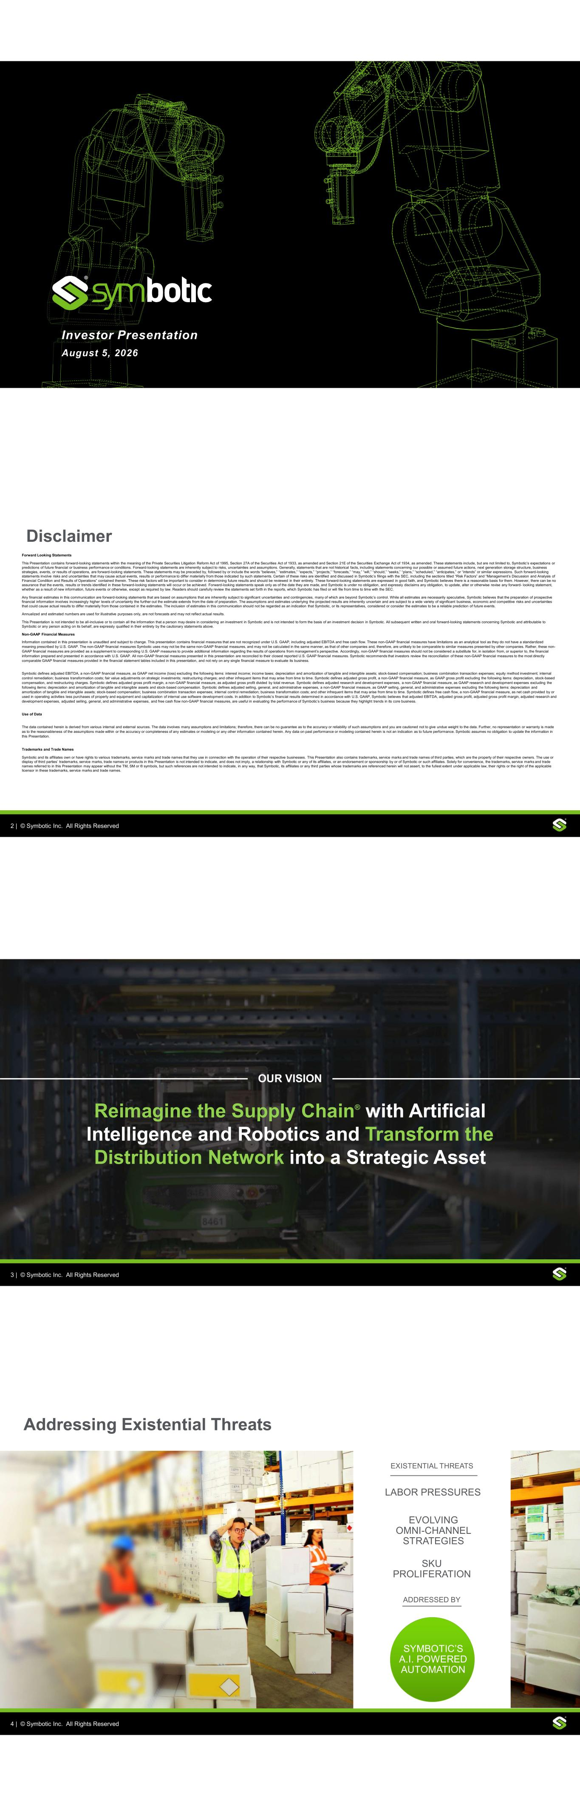

1 | © Symbotic, Inc. All Rights Reserved | Proprietary and ConfidentialInc. Al Rights Reserved Investor Presentation August 5, 2026 2 | © Symbotic, Inc. All Rights Reserved | Proprietary and ConfidentialInc. Al Rights Reserved Disclaimer Forward Looking Statements This Presentation contains forward-looking statements within the meaning of the Private Securities Litigation Reform Act of 1995, Section 27A of the Securities Act of 1933, as amended and Section 21E of the Securities Exchange Act of 1934, as amended. These statements include, but are not limited to, Symbotic’s expectations or predictions of future financial or business performance or conditions. Forward-looking statements are inherently subject to risks, uncertainties and assumptions. Generally, statements that are not historical facts, including statements concerning our possible or assumed future actions, next generation storage structure, business strategies, events, or results of operations, are forward-looking statements. These statements may be preceded by, followed by or include the words “believes,” “estimates,” “expects,” “projects,” “forecasts,” “may,” “will,” “should,” “seeks,” “plans,” “scheduled,” “anticipates,” or “intends” or similar expressions. Such forward-looking statements involve risks and uncertainties that may cause actual events, results or performance to differ materially from those indicated by such statements. Certain of these risks are identified and discussed in Symbotic’s filings with the SEC, including the sections titled “Risk Factors” and “Management’s Discussion and Analysis of Financial Condition and Results of Operations” contained therein. These risk factors will be important to consider in determining future results and should be reviewed in their entirety. These forward-looking statements are expressed in good faith, and Symbotic believes there is a reasonable basis for them. However, there can be no assurance that the events, results or trends identified in these forward-looking statements will occur or be achieved. Forward-looking statements speak only as of the date they are made, and Symbotic is under no obligation, and expressly disclaims any obligation, to update, alter or otherwise revise any forward- looking statement, whether as a result of new information, future events or otherwise, except as required by law. Readers should carefully review the statements set forth in the reports, which Symbotic has filed or will file from time to time with the SEC. Any financial estimates in this communication are forward-looking statements that are based on assumptions that are inherently subject to significant uncertainties and contingencies, many of which are beyond Symbotic’s control. While all estimates are necessarily speculative, Symbotic believes that the preparation of prospective financial information involves increasingly higher levels of uncertainty the further out the estimate extends from the date of preparation. The assumptions and estimates underlying the projected results are inherently uncertain and are subject to a wide variety of significant business, economic and competitive risks and uncertainties that could cause actual results to differ materially from those contained in the estimates. The inclusion of estimates in this communication should not be regarded as an indication that Symbotic, or its representatives, considered or consider the estimates to be a reliable prediction of future events. Annualized and estimated numbers are used for illustrative purposes only, are not forecasts and may not reflect actual results. This Presentation is not intended to be all-inclusive or to contain all the information that a person may desire in considering an investment in Symbotic and is not intended to form the basis of an investment decision in Symbotic. All subsequent written and oral forward-looking statements concerning Symbotic and attributable to Symbotic or any person acting on its behalf, are expressly qualified in their entirety by the cautionary statements above. Non-GAAP Financial Measures Information contained in this presentation is unaudited and subject to change. This presentation contains financial measures that are not recognized under U.S. GAAP, including adjusted EBITDA and free cash flow. These non-GAAP financial measures have limitations as an analytical tool as they do not have a standardized meaning prescribed by U.S. GAAP. The non-GAAP financial measures Symbotic uses may not be the same non-GAAP financial measures, and may not be calculated in the same manner, as that of other companies and, therefore, are unlikely to be comparable to similar measures presented by other companies. Rather, these non- GAAP financial measures are provided as a supplement to corresponding U.S. GAAP measures to provide additional information regarding the results of operations from management’s perspective. Accordingly, non-GAAP financial measures should not be considered a substitute for, in isolation from, or superior to, the financial information prepared and presented in accordance with U.S. GAAP. All non-GAAP financial measures presented in this presentation are reconciled to their closest reported U.S. GAAP financial measures. Symbotic recommends that investors review the reconciliation of these non-GAAP financial measures to the most directly comparable GAAP financial measures provided in the financial statement tables included in this presentation, and not rely on any single financial measure to evaluate its business. Symbotic defines adjusted EBITDA, a non-GAAP financial measure, as GAAP net income (loss) excluding the following items: interest income; income taxes; depreciation and amortization of tangible and intangible assets; stock-based compensation; business combination transaction expenses; equity method investment; internal control remediation; business transformation costs; fair value adjustments on strategic investments; restructuring charges; and other infrequent items that may arise from time to time. Symbotic defines adjusted gross profit, a non-GAAP financial measure, as GAAP gross profit excluding the following items: depreciation, stock-based compensation, and restructuring charges. Symbotic defines adjusted gross profit margin, a non-GAAP financial measure, as adjusted gross profit divided by total revenue. Symbotic defines adjusted research and development expenses, a non-GAAP financial measure, as GAAP research and development expenses excluding the following items: depreciation and amortization of tangible and intangible assets and stock-based compensation. Symbotic defines adjusted selling, general, and administrative expenses, a non-GAAP financial measure, as GAAP selling, general, and administrative expenses excluding the following items: depreciation and amortization of tangible and intangible assets; stock-based compensation; business combination transaction expenses; internal control remediation; business transformation costs; and other infrequent items that may arise from time to time. Symbotic defines free cash flow, a non-GAAP financial measure, as net cash provided by or used in operating activities less purchases of property and equipment and capitalization of internal use software development costs. In addition to Symbotic’s financial results determined in accordance with U.S. GAAP, Symbotic believes that adjusted EBITDA, adjusted gross profit, adjusted gross profit margin, adjusted research and development expenses, adjusted selling, general, and administrative expenses, and free cash flow non-GAAP financial measures, are useful in evaluating the performance of Symbotic’s business because they highlight trends in its core business. Use of Data The data contained herein is derived from various internal and external sources. The data involves many assumptions and limitations; therefore, there can be no guarantee as to the accuracy or reliability of such assumptions and you are cautioned not to give undue weight to the data. Further, no representation or warranty is made as to the reasonableness of the assumptions made within or the accuracy or completeness of any estimates or modeling or any other information contained herein. Any data on past performance or modeling contained herein is not an indication as to future performance. Symbotic assumes no obligation to update the information in this Presentation. Trademarks and Trade Names Symbotic and its affiliates own or have rights to various trademarks, service marks and trade names that they use in connection with the operation of their respective businesses. This Presentation also contains trademarks, service marks and trade names of third parties, which are the property of their respective owners. The use or display of third parties’ trademarks, service marks, trade names or products in this Presentation is not intended to indicate, and does not imply, a relationship with Symbotic or any of its affiliates, or an endorsement or sponsorship by or of Symbotic or such affiliates. Solely for convenience, the trademarks, service marks and trade names referred to in this Presentation may appear without the TM, SM or ® symbols, but such references are not intended to indicate, in any way, that Symbotic, its affiliates or any third parties whose trademarks are referenced herein will not assert, to the fullest extent under applicable law, their rights or the right of the applicable licensor in these trademarks, service marks and trade names. 3 | © Symbotic, Inc. All Rights Reserved | Proprietary and ConfidentialInc. Al Rights Reserved OUR VISION Reimagine the Supply Chain® with Artificial Intelligence and Robotics and Transform the Distribution Network into a Strategic Asset 4 | © Symbotic, Inc. All Rights Reserved | Proprietary and ConfidentialInc. Al Rights Reserved LABOR PRESSURES SKU PROLIFERATION EVOLVING OMNI-CHANNEL STRATEGIES SYMBOTIC’S A.I. POWERED AUTOMATION EXISTENTIAL THREATS ADDRESSED BY Addressing Existential Threats

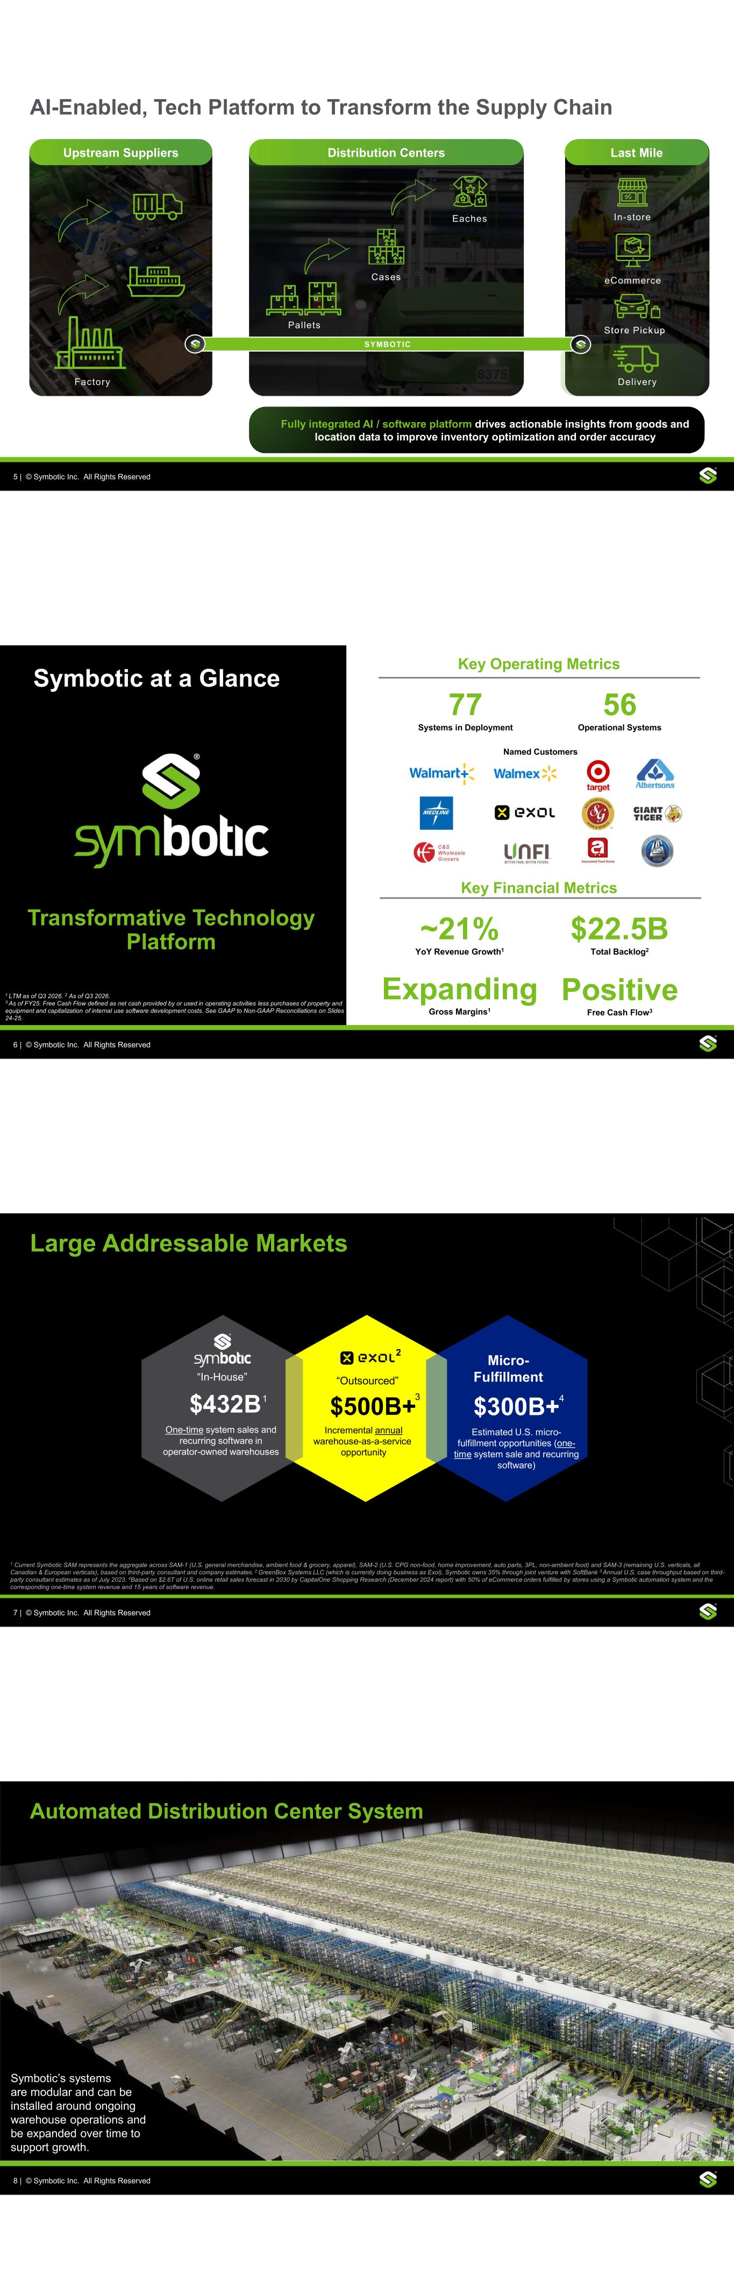
5 | © Symbotic, Inc. All Rights Reserved | Proprietary and ConfidentialInc. Al Rights Reserved AI-Enabled, Tech Platform to Transform the Supply Chain Upstream Suppliers Distribution Centers Fully integrated AI / software platform drives actionable insights from goods and location data to improve inventory optimization and order accuracy Pallets Cases Eaches Last Mile In-store Store Pickup eCommerce SYMBOTIC Factory Delivery 6 | © Symbotic, Inc. All Rights Reserved | Proprietary and ConfidentialInc. Al Rights Reserved Transformative Technology Platform Key Financial Metrics ~21% YoY Revenue Growth1 Expanding Gross Margins1 $22.5B Total Backlog2 Key Operating Metrics 77 Systems in Deployment 56 Operational Systems Named Customers Symbotic at a Glance 1 LTM as of Q3 2026. 2 As of Q3 2026. 3 As of FY25. Free Cash Flow defined as net cash provided by or used in operating activities less purchases of property and equipment and capitalization of internal use software development costs. See GAAP to Non-GAAP Reconciliations on Slides 24-25. Positive Free Cash Flow3 7 | © Symbotic, Inc. All Rights Reserved | Proprietary and Confidential Inc. Al Rights Reserved Large Addressable Markets 1 Current Symbotic SAM represents the aggregate across SAM-1 (U.S. general merchandise, ambient food & grocery, apparel), SAM-2 (U.S. CPG non-food, home improvement, auto parts, 3PL, non-ambient food) and SAM-3 (remaining U.S. verticals, all Canadian & European verticals), based on third-party consultant and company estimates. 2 GreenBox Systems LLC (which is currently doing business as Exol), Symbotic owns 35% through joint venture with SoftBank 3 Annual U.S. case throughput based on third- party consultant estimates as of July 2023. 4Based on $2.6T of U.S. online retail sales forecast in 2030 by CapitalOne Shopping Research (December 2024 report) with 50% of eCommerce orders fulfilled by stores using a Symbotic automation system and the corresponding one-time system revenue and 15 years of software revenue. 2 $500B+ “Outsourced” Incremental annual warehouse-as-a-service opportunity 3$432B One-time system sales and recurring software in operator-owned warehouses “In-House” 1 Micro- Fulfillment $300B+ Estimated U.S. micro- fulfillment opportunities (one- time system sale and recurring software) 4 8 | © Symbotic, Inc. All Rights Reserved | Proprietary and ConfidentialInc. Al Rights Reserved Automated Distribution Center System Symbotic’s systems are modular and can be installed around ongoing warehouse operations and be expanded over time to support growth.

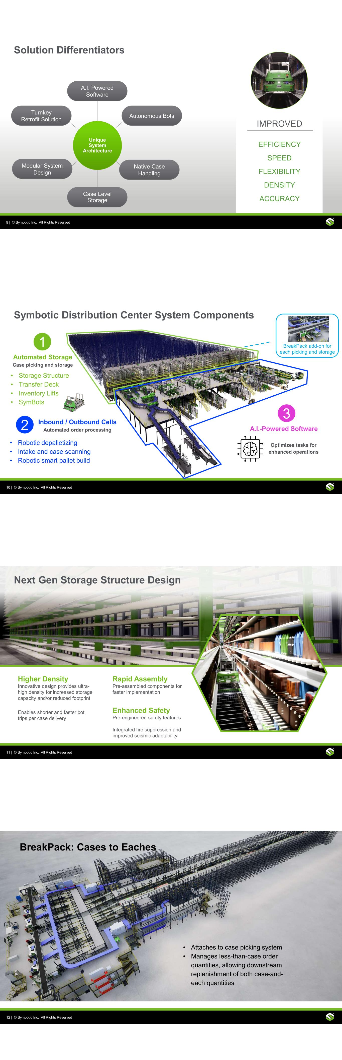
9 | © Symbotic, Inc. All Rights Reserved | Proprietary and ConfidentialInc. Al Rights Reserved Solution Differentiators A.I. Powered Software Autonomous Bots Native Case Handling Case Level Storage Modular System Design Turnkey Retrofit Solution Unique System Architecture IMPROVED EFFICIENCY SPEED FLEXIBILITY DENSITY ACCURACY 10 | © Symbotic, Inc. All Rights Reserved | Proprietary and ConfidentialInc. Al Rights Reserved BreakPack add-on for each picking and storage • Storage Structure • Transfer Deck • Inventory Lifts • SymBots Automated Storage Case picking and storage A.I.-Powered Software Optimizes tasks for enhanced operations 1 2 3 Symbotic Distribution Center System Components • Robotic depalletizing • Intake and case scanning • Robotic smart pallet build Inbound / Outbound Cells Automated order processing 11 | © Symbotic, Inc. All Rights Reserved | Proprietary and ConfidentialInc. Al Rights Reserved Next Gen Storage Structure Design Higher Density Innovative design provides ultra- high density for increased storage capacity and/or reduced footprint Enables shorter and faster bot trips per case delivery Rapid Assembly Pre-assembled components for faster implementation Enhanced Safety Pre-engineered safety features Integrated fire suppression and improved seismic adaptability 12 | © Symbotic, Inc. All Rights Reserved | Proprietary and ConfidentialInc. Al Rights Reserved BreakPack: Cases to Eaches • Attaches to case picking system • Manages less-than-case order quantities, allowing downstream replenishment of both case-and- each quantities

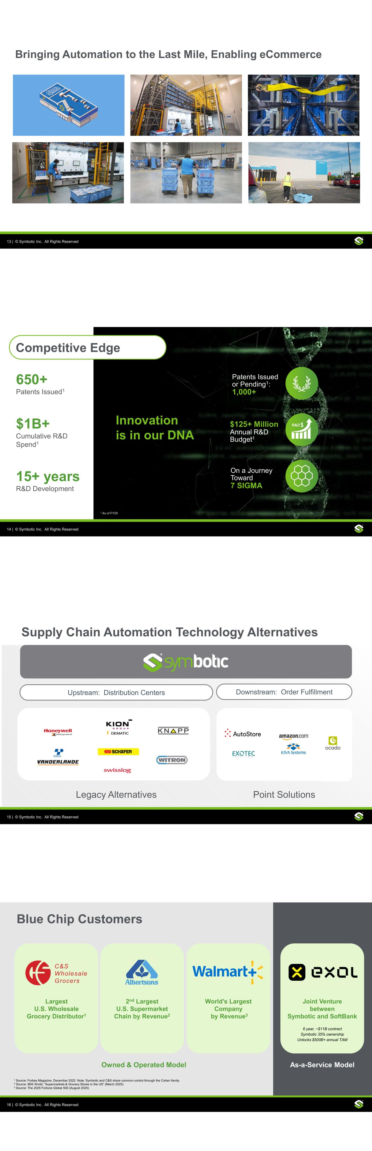
13 | © Symbotic, Inc. All Rights Reserved | Proprietary and ConfidentialInc. Al Rights Reserved Bringing Automation to the Last Mile, Enabling eCommerce 14 | © Symbotic, Inc. All Rights Reserved | Proprietary and ConfidentialInc. Al Rights Reserved 650+ Patents Issued1 $1B+ Cumulative R&D Spend1 15+ years R&D Development On a Journey Toward 7 SIGMA $125+ Million Annual R&D Budget1 Innovation is in our DNA Patents Issued or Pending1: 1,000+ Competitive Edge 1 As of FY25 15 | © Symbotic, Inc. All Rights Reserved | Proprietary and ConfidentialInc. Al Rights Reserved Supply Chain Automation Technology Alternatives 15 Point Solutions 0 Legacy Alternatives Upstream: Distribution Centers Downstream: Order Fulfillment 16 | © Symbotic, Inc. All Rights Reserved | Proprietary and ConfidentialInc. Al Rights Reserved Blue Chip Customers Largest U.S. Wholesale Grocery Distributor1 2nd Largest U.S. Supermarket Chain by Revenue2 World’s Largest Company by Revenue3 1 Source: Forbes Magazine, December 2022. Note: Symbotic and C&S share common control through the Cohen family. 2 Source: IBIS World, “Supermarkets & Grocery Stores in the US” (March 2025) 3 Source: The 2025 Fortune Global 500 (August 2025) Joint Venture between Symbotic and SoftBank 6 year, ~$11B contract Symbotic 35% ownership Unlocks $500B+ annual TAM Owned & Operated Model As-a-Service Model

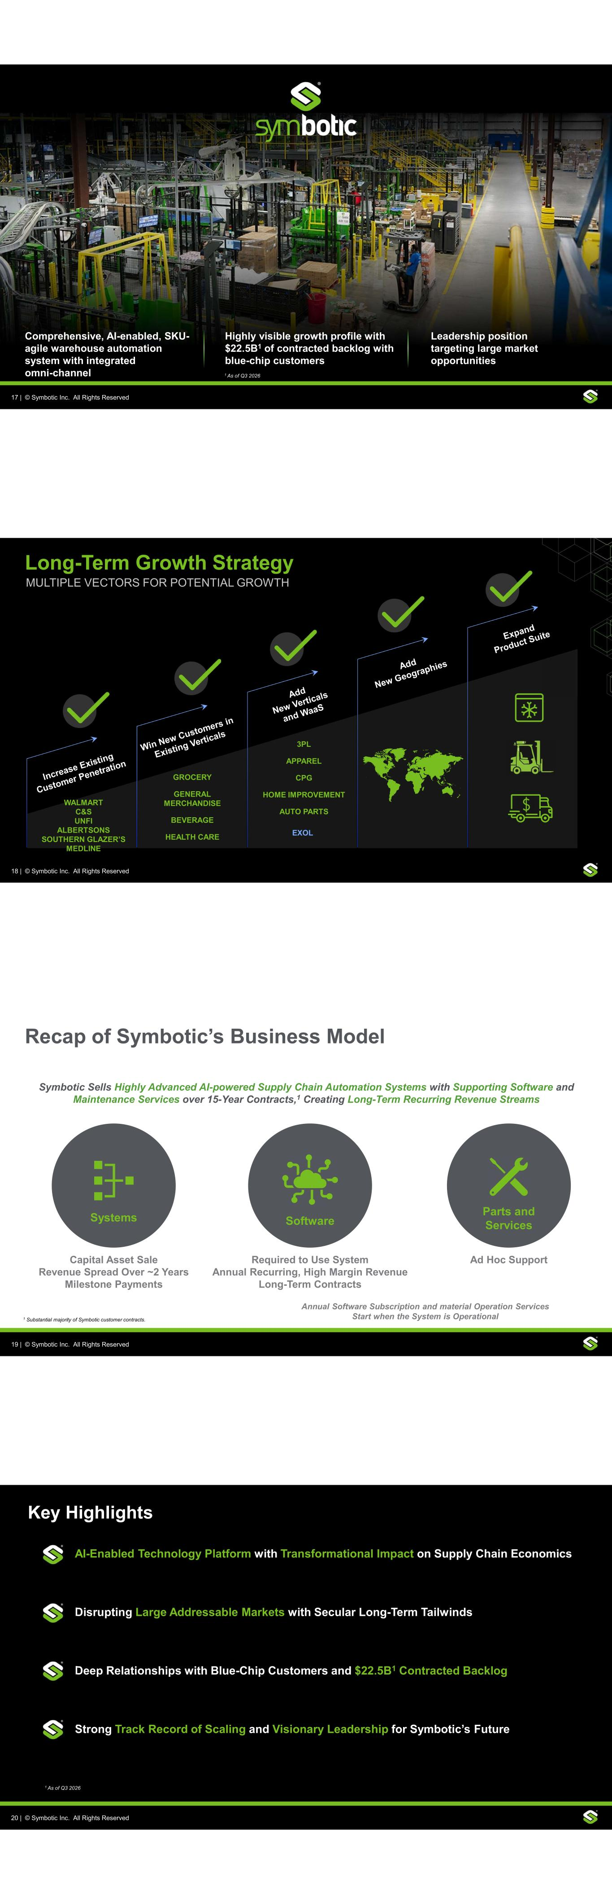
17 | © Symbotic, Inc. All Rights Reserved | Proprietary and Confidential Inc. Al Rights Reserved Comprehensive, AI-enabled, SKU- agile warehouse automation system with integrated omni-channel Highly visible growth profile with $22.5B1 of contracted backlog with blue-chip customers Leadership position targeting large market opportunities 1 As of Q3 2026 18 | © Symbotic, Inc. All Rights Reserved | Proprietary and ConfidentialInc. Al Rights Reserved Long-Term Growth Strategy MULTIPLE VECTORS FOR POTENTIAL GROWTH GROCERY GENERAL MERCHANDISE BEVERAGE HEALTH CARE 3PL APPAREL CPG HOME IMPROVEMENT AUTO PARTS WALMART C&S UNFI ALBERTSONS SOUTHERN GLAZER’S MEDLINE EXOL 19 | © Symbotic, Inc. All Rights Reserved | Proprietary and ConfidentialInc. Al Rights Reserved Recap of Symbotic’s Business Model Symbotic Sells Highly Advanced AI-powered Supply Chain Automation Systems with Supporting Software and Maintenance Services over 15-Year Contracts,1 Creating Long-Term Recurring Revenue Streams SoftwareSystems Parts and Services Capital Asset Sale Revenue Spread Over ~2 Years Milestone Payments Required to Use System Annual Recurring, High Margin Revenue Long-Term Contracts Ad Hoc Support Annual Software Subscription and material Operation Services Start when the System is Operational1 Substantial majority of Symbotic customer contracts. 20 | © Symbotic, Inc. All Rights Reserved | Proprietary and ConfidentialInc. Al Rights Reserved AI-Enabled Technology Platform with Transformational Impact on Supply Chain Economics Disrupting Large Addressable Markets with Secular Long-Term Tailwinds Deep Relationships with Blue-Chip Customers and $22.5B1 Contracted Backlog Strong Track Record of Scaling and Visionary Leadership for Symbotic’s Future Key Highlights 1 As of Q3 2026

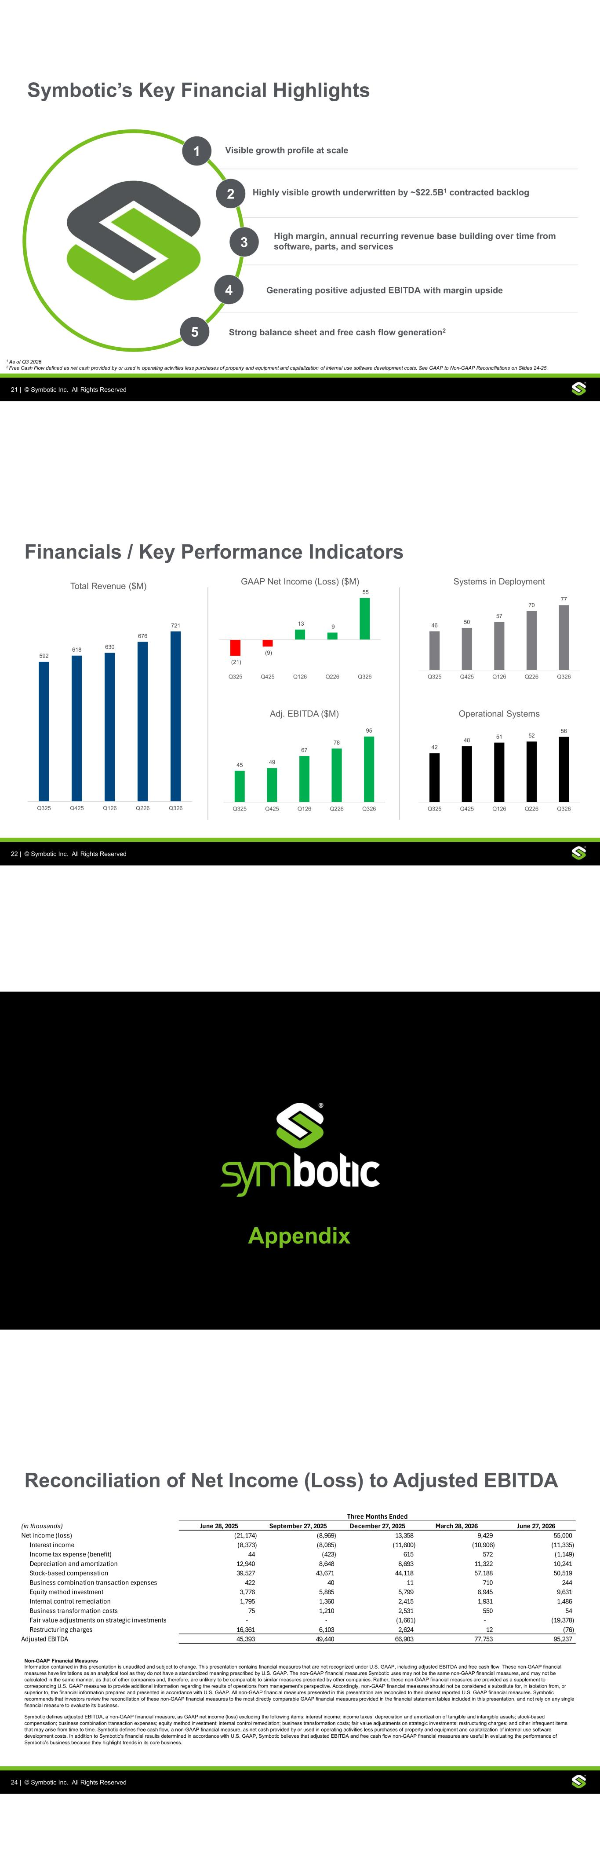
21 | © Symbotic, Inc. All Rights Reserved | Proprietary and ConfidentialInc. Al Rights Reserved Symbotic’s Key Financial Highlights High margin, annual recurring revenue base building over time from software, parts, and services Strong balance sheet and free cash flow generation2 Generating positive adjusted EBITDA with margin upside Highly visible growth underwritten by ~$22.5B1 contracted backlog Visible growth profile at scale 5 4 3 2 1 2 Free Cash Flow defined as net cash provided by or used in operating activities less purchases of property and equipment and capitalization of internal use software development costs. See GAAP to Non-GAAP Reconciliations on Slides 24-25. 1 As of Q3 2026 22 | © Symbotic, Inc. All Rights Reserved | Proprietary and ConfidentialInc. Al Rights Reserved Financials / Key Performance Indicators 592 618 630 676 721 Q325 Q425 Q126 Q226 Q326 Total Revenue ($M) 46 50 57 70 77 Q325 Q425 Q126 Q226 Q326 Systems in Deployment 42 48 51 52 56 Q325 Q425 Q126 Q226 Q326 Operational Systems 45 49 67 78 95 Q325 Q425 Q126 Q226 Q326 Adj. EBITDA ($M) (21) (9) 13 9 55 Q325 Q425 Q126 Q226 Q326 GAAP Net Income (Loss) ($M) Appendix 24 | © Symbotic, Inc. All Rights Reserved | Proprietary and ConfidentialInc. Al Rights Reserved Reconciliation of Net Income (Loss) to Adjusted EBITDA Non-GAAP Financial Measures Information contained in this presentation is unaudited and subject to change. This presentation contains financial measures that are not recognized under U.S. GAAP, including adjusted EBITDA and free cash flow. These non-GAAP financial measures have limitations as an analytical tool as they do not have a standardized meaning prescribed by U.S. GAAP. The non-GAAP financial measures Symbotic uses may not be the same non-GAAP financial measures, and may not be calculated in the same manner, as that of other companies and, therefore, are unlikely to be comparable to similar measures presented by other companies. Rather, these non-GAAP financial measures are provided as a supplement to corresponding U.S. GAAP measures to provide additional information regarding the results of operations from management’s perspective. Accordingly, non-GAAP financial measures should not be considered a substitute for, in isolation from, or superior to, the financial information prepared and presented in accordance with U.S. GAAP. All non-GAAP financial measures presented in this presentation are reconciled to their closest reported U.S. GAAP financial measures. Symbotic recommends that investors review the reconciliation of these non-GAAP financial measures to the most directly comparable GAAP financial measures provided in the financial statement tables included in this presentation, and not rely on any single financial measure to evaluate its business. Symbotic defines adjusted EBITDA, a non-GAAP financial measure, as GAAP net income (loss) excluding the following items: interest income; income taxes; depreciation and amortization of tangible and intangible assets; stock-based compensation; business combination transaction expenses; equity method investment; internal control remediation; business transformation costs; fair value adjustments on strategic investments; restructuring charges; and other infrequent items that may arise from time to time. Symbotic defines free cash flow, a non-GAAP financial measure, as net cash provided by or used in operating activities less purchases of property and equipment and capitalization of internal use software development costs. In addition to Symbotic’s financial results determined in accordance with U.S. GAAP, Symbotic believes that adjusted EBITDA and free cash flow non-GAAP financial measures are useful in evaluating the performance of Symbotic’s business because they highlight trends in its core business. (in thousands) June 28, 2025 September 27, 2025 December 27, 2025 March 28, 2026 June 27, 2026 Net income (loss) (21,174) (8,969) 13,358 9,429 55,000 Interest income (8,373) (8,085) (11,600) (10,906) (11,335) Income tax expense (benefit) 44 (423) 615 572 (1,149) Depreciation and amortization 12,940 8,648 8,693 11,322 10,241 Stock-based compensation 39,527 43,671 44,118 57,188 50,519 Business combination transaction expenses 422 40 11 710 244 Equity method investment 3,776 5,885 5,799 6,945 9,631 Internal control remediation 1,795 1,360 2,415 1,931 1,486 Business transformation costs 75 1,210 2,531 550 54 Fair value adjustments on strategic investments - - (1,661) - (19,378) Restructuring charges 16,361 6,103 2,624 12 (76) Adjusted EBITDA 45,393 49,440 66,903 77,753 95,237 Three Months Ended

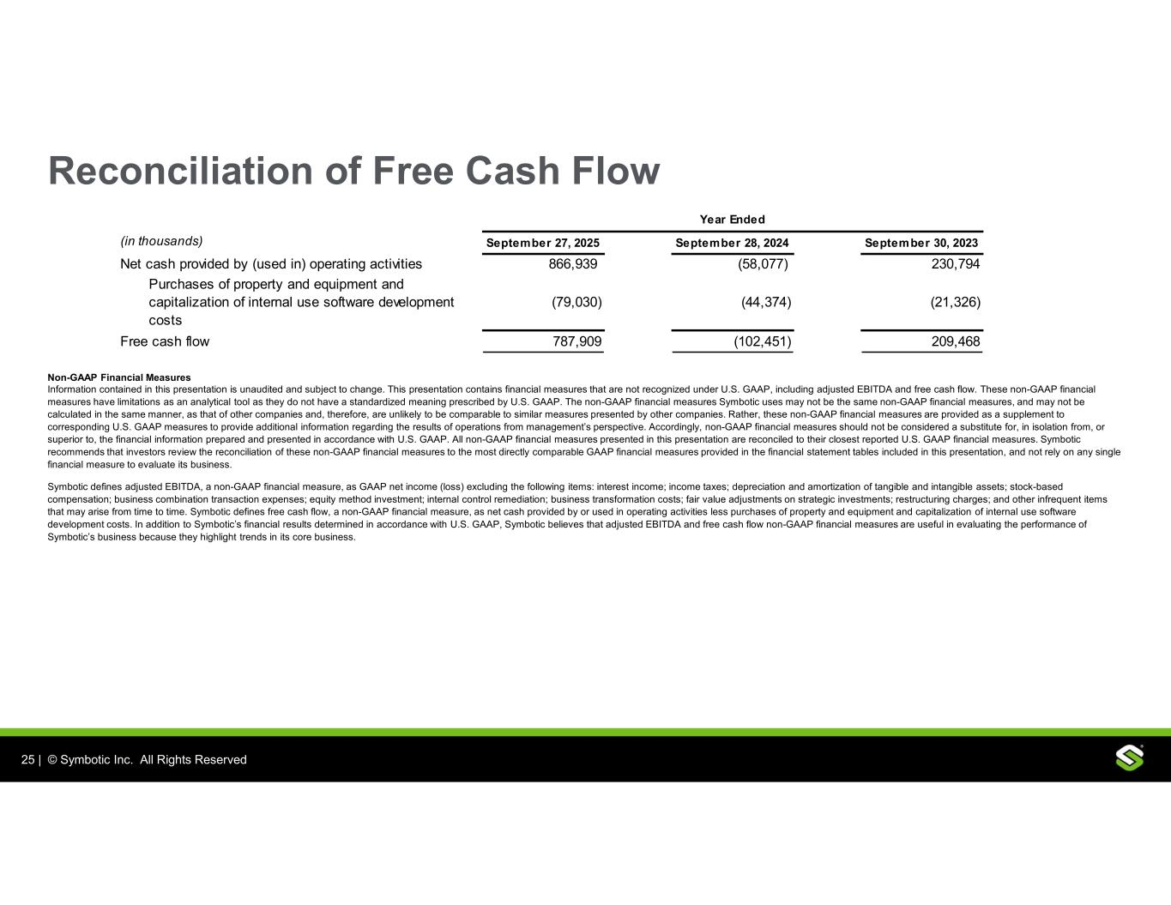
25 | © Symbotic, Inc. All Rights Reserved | Proprietary and ConfidentialInc. Al Rights Reserved Reconciliation of Free Cash Flow Non-GAAP Financial Measures Information contained in this presentation is unaudited and subject to change. This presentation contains financial measures that are not recognized under U.S. GAAP, including adjusted EBITDA and free cash flow. These non-GAAP financial measures have limitations as an analytical tool as they do not have a standardized meaning prescribed by U.S. GAAP. The non-GAAP financial measures Symbotic uses may not be the same non-GAAP financial measures, and may not be calculated in the same manner, as that of other companies and, therefore, are unlikely to be comparable to similar measures presented by other companies. Rather, these non-GAAP financial measures are provided as a supplement to corresponding U.S. GAAP measures to provide additional information regarding the results of operations from management’s perspective. Accordingly, non-GAAP financial measures should not be considered a substitute for, in isolation from, or superior to, the financial information prepared and presented in accordance with U.S. GAAP. All non-GAAP financial measures presented in this presentation are reconciled to their closest reported U.S. GAAP financial measures. Symbotic recommends that investors review the reconciliation of these non-GAAP financial measures to the most directly comparable GAAP financial measures provided in the financial statement tables included in this presentation, and not rely on any single financial measure to evaluate its business. Symbotic defines adjusted EBITDA, a non-GAAP financial measure, as GAAP net income (loss) excluding the following items: interest income; income taxes; depreciation and amortization of tangible and intangible assets; stock-based compensation; business combination transaction expenses; equity method investment; internal control remediation; business transformation costs; fair value adjustments on strategic investments; restructuring charges; and other infrequent items that may arise from time to time. Symbotic defines free cash flow, a non-GAAP financial measure, as net cash provided by or used in operating activities less purchases of property and equipment and capitalization of internal use software development costs. In addition to Symbotic’s financial results determined in accordance with U.S. GAAP, Symbotic believes that adjusted EBITDA and free cash flow non-GAAP financial measures are useful in evaluating the performance of Symbotic’s business because they highlight trends in its core business. (in thousands) September 27, 2025 September 28, 2024 September 30, 2023 Net cash provided by (used in) operating activities 866,939 (58,077) 230,794 Purchases of property and equipment and capitalization of internal use software development costs (79,030) (44,374) (21,326) Free cash flow 787,909 (102,451) 209,468 Year Ended

